Lets load are app faster

Hi all.

I am a front-end developer at Broadridge, while building one of our (great 😊 ) Apps I got a task: “Make our loading performance better in our app”. with the help of my colleagues we did some good work (in my eyes) I will try to summarize some ideas that can my help you also to increase your app loading time.

I will try to write it all here and show with some images, if you would like to see code I uploaded a repository to GitHub with the same problems that we had in our project, and you can look at the code examples and “play” with them yourself. (if you do read the readme file for running the app correctly)

The goal of this article is to load the first page of the app as fast as we can

Starting point:

If you look at the repository you can look at branch “master”, if not this this our status after building for production the app:

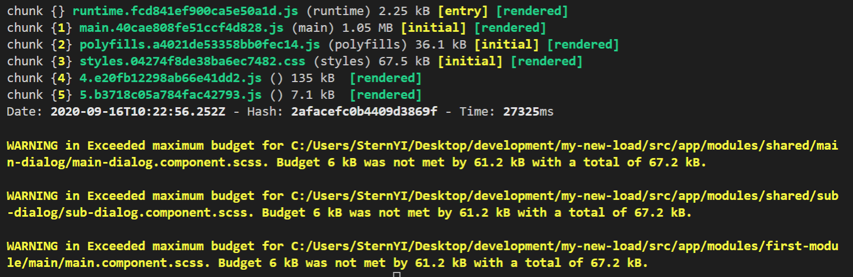

After analyzing the loading status this is what we get: (I changed the network settings to simulate a real remote server which also has some latency issues)



This took about 10.5 seconds.

This is a bad starting point

Let’s analyze the problems that we have:

1. We have a **very big** main.js file.
2. Our API calls take a long time.
3. There is a long bottleneck that looks like this:   
   Load main.js => load first module => login API => first apicall fo app data

We will try to make evert topic to look better and make our simple app better…